**Grad Project Milestone1**

**Keke Wu**

**I. Description**

**Inspiration:** The basic idea is to create an android app as a handy tool to help field researchers record the data they collect during fieldwork. While outside, bringing a pen and a notebook could be inconvenient for the scientists. Due to the limitation, it could also be hard for scientists to record other data types besides number and texts on a notebook. Data management is another big issue, pure paper-based data could be easy to get lost and disorganized.

**Goal:** Create a handy mobile app to help researchers record data as much as possible. Providing a high efficient tool for fieldwork.

**Target Audience:** Field researchers

**II. Research**

Most of the current data collection apps have similar looks and functions, which is kind of boring. They all have the form structure and text-based data selection. Some of them tend to be classified into too many different categories, which can result being distracting and somehow lower the efficiency during high-intensity field work. My app is designed to be simple but practical. The data to be collected is grouped by data type, ranging from numeric data, text, images to multimedia data, which hopefully will make it easier for database management later on. Also, I will put more emphasize on the UI design, aiming at making a more fluent and efficient user experience.

**III. Content**

I will try to use as many as appropriate images, such as icons, instead of dull texts to visualize these data. For this part, I will design in Adobe software.

As for the specific data entry, I will do some research on current fieldwork and see what kinds of data are most wanted by the researchers. I will do some improvements based on my research and try to create a SQLite database on the Android phone to store those data.

**IV. Paper Prototype**

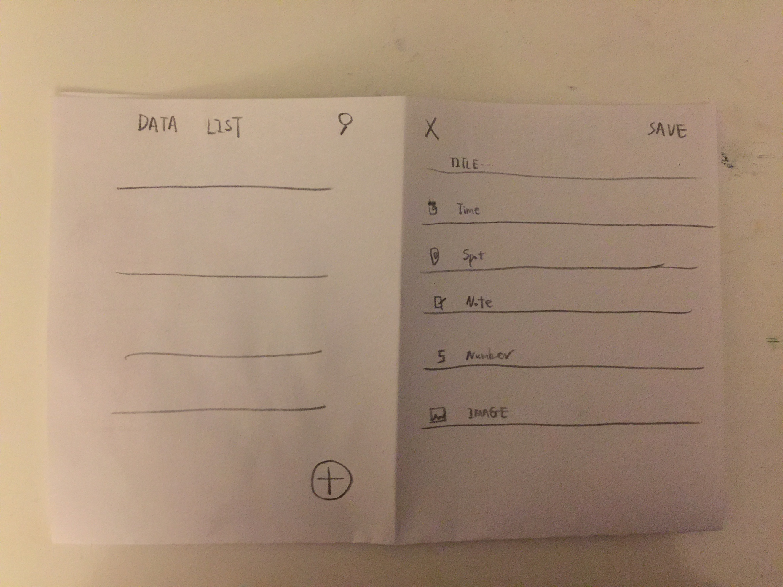

There will be at least two views for this app, one is the home screen holding all the data that has been collected. On the top right corner, there is a search icon, which will help the user to find the data they want quickly. On the right bottom corner, there is a plus icon, which indicates having a new data and leads to another screen. The second screen will allow the user to type in the data as shown in the picture. Its function still needs to be refined, and will obey the principles to be simple and efficient.